Introduction
(Oracle, 2021), A relational database is a collection of related data organized into tables that are linked through primary keys and foreign keys. This structure enables data to be stored efficiently while maintaining data integrity and consistency. Relational databases are managed using Relational Database Management Systems (RDBMS) such as MySQL and Oracle. Relational databases are widely used by organizations because they reduce data redundancy, supports data security and enable easy manipulation and management of information.

This assignment focuses on the design and implementation of a well-structured and secure relational database system for Bloomfield Garden Centre which currently relies on using paper-based system for managing products, employees, customer, sales transactions. As the business continues to expand, paper-based method of storing data has become more inefficient and prone to errors.

The aim of the assignment is to develop a relational database that supports the operational requirements of Bloomfield Garden Centre. The database will be designed using normalization skills up to Third Normal Form(3NF) to minimize data redundancy and improve data integrity. In addition to that, an Entity Relational Diagram (ERD) will be developed to showcase the relationships between entities.

Normalization

- Unnormalized Form
Customer_ID | Customer_Name | Customer_Phonenumber | Session_Title | Session_Date | Employee_Assigned | Equipment_Used | Products_Purchased | Customer_Status
1 | John Banda | 0991243675 | Organic Gardening | 2026-06-15 | Peter, Mary | Shovel, Projector | Rose Plant, Watering Can | Active
2 | Sarah Phiri | 0880213436 | DIY Home Garden | 2026-06-20 | James, Peter | Hoe, Microphone | Tomato Seed, Fertilizer | Active
3 | John Kaliyeka | 0999302267 | DIY Home Garden | 2026-06-20 | James, Peter | Hoe, Microphone | Tomato Seed | Inactive
4 | Doreen Jaliwa | 08921342 | Organic Gardening | 2026-06-15 | Peter,Mary | Shovel, Projector | Rose Plant | Active
5 | Grace Mbewe | 0991243675 | Sustainable Farming | 2026-07-10 | Patrick | Projector, Speaker | Fertilizer, Garden Gloves | Active

The initial data structure was created using a single table containing customer information, workshop details, employees assigned to a workshop, equipment used in a workshop and purchased products. The table is considered to be unnormalized Form (UNF) because it contains repeating data in single fields and the data is mixed up making it difficult to manage.

- Third Normal Form(3NF)
- Customer
Customer_Id | Customer_Firstname | Customer_Lastname | Customer_Email | Customer_Gender | Customer_Phonenumber | Customer_Address | Customer_Status | Customer_Created_At
1 | John | Banda | john@gmail.com | Male | 0991243675 | Area 23 | Active | 20-01-2026
2 | Sarah | Phiri | sarah@gmail.com | Female | 0880213436 | Area 21 | Active | 20-09-2025
3 | John | Kaliyeka | jk@gmail.com | Male | 0999302267 | Area 22 | Inactive | 20-01-2024
4 | Doreen | Jaliwa | doreen@gmail.com | Female | 0880213425 | Area 49 | Active | 12-01-2023
5 | Grace | Mbewe | grace@gmail.com | Female | 0991243675 | Area 15 | Active | 30-05-2026

- Employee_Role
Role_Id | Role_name | Role_Description | Role_Date_Created
1 | Workshop Facilitator | Workshop hosting, Farm work | 2025-01-01
2 | Customer Care | Customer care, Advising | 2025-01-01
3 | Plant Specialist | Plant preparation | 2025-01-01
4 | Field Worker | Physical work structuring | 2025-01-01
5 | Finance Officer | Finance handling and public speaking | 2025-01-01

- Employee_Qualification
Qualification_Id | Qualification_Name
1 | Bachelor’s Degree in Cropping Systems
2 | Certificate in Sales Management
3 | Diploma in Organic Chemistry
4 | Certificate in Land Labouring
5 | Master’s Degree in Agricultural Economics

- Employee
Employee_Id | Employee_Firstname | Employee_Lastname | Employee_Email | Employee_Phonenumber | Employee_Working Hours | Employee_Status | Qualification_Id(FK) | Role_Id(FK)
1 | Peter | Zuze | peter@greenfield.com | 0999201829 | 7 | Active | 1 | 1
2 | Mary | Banda | mary@greenfield.com | 0889254262 | 16 | Active | 2 | 2
3 | James | Lawi | james@greenfield.com | 0893242634 | 12 | Active | 3 | 3
4 | Patrick | Phiri | patrick@greenfield.com | 0981245346 | 16 | Active | 4 | 4
5 | Joana | Linde | joana@greenfield.com | 0885424256 | 4 | Active | 5 | 5
- Supplier
Supplier_Id | Supplier_name | Supplier_Email | Supplier_Phonenumber | Supplier_Location
1 | AgriSupplies Ltd | info@agrisupplies.mw | 012345678 | Lilongwe
2 | Ferticore Ltd | Sales@ferticore.mw | 098765432 | Blantyre

- Product_Category
Category_Id | Category_Name
1 | Plant
2 | Accessory
3 | Crop Yield

- Product
Product_Id | Product_Name | Product_Description | Product_Price | Product_Stock_Quantity | Product_Date_Added | Category_Id(FK) | Supplier_Id
1 | Rose Plant | Hybrid tea rose | 10000.00 | 5 | 20-4-2026 | 1 | 1
2 | Watering Can | 10L galvanized steel | 15000.00 | 2 | 21-5-2026 | 2 | 1
3 | Tomato Seed | Organic heirloom | 1000.00 | 10 | 22-6-2026 | 1 | 1
4 | Fertilizer | NPK 23-21-0+4S | 150000.00 | 15 | 23-1-2026 | 3 | 2
5 | Garden Gloves | Heavy-duty leather | 10000.00 | 20 | 27-12-2026 | 2 | 1

- Training
Training_Id | Training_Name | Training_Description | Training_Duration | Training_Level
1 | Organic Farming Basics | Introduction to organic methods of farming | 3 days | Beginner
2 | Pest Management | Natural pest control technniques to enhance the growth of the plants | 2 days | Intermediate
3 | Soil Health | Understanding soil composition and how to take care of it | 1 day | Beginner
4 | Advanced Irrigation | Water management systems | 2 day | Advanced
5 | Customer service skills | Effective communication between customers and employees

- Session_Type
Session_Type_Id | Session_Name | Session_Description
1 | Workshop | Hands-on practical training session
2 | Seminar | Lecture-based educational session
3 | Field Training | Outdoor practical demostration

- Session_Table

Session_Id | Session_Title | Session_Description | Session_Date | Session_Time | Session_Location | Session_Max_Attendance | Status | Session_Type_Id(FK)
1 | Organic Gardening | Intro to chemical-free gardening | 2026-06-15 | 09:00 AM | Main Hall | 20 | Scheduled | 1
2 | DIY Home Garden | Building backyard vegetable plots | 2026-06-20 | 10:00 AM | Garden Plot A | 15 | Scheduled | 1
3 | Sustainable Farming | Long-term soil health practice | 2026-07-10 | 08:00 AM | Conference Room | 30 | Scheduled | 3

- Equipment
Equipment_Id (PK) | Equipment_Name | Equipment_Quantity | Equipment_Description | Equipment_Status | Equipment_Cost | Equipment_Purchase_Date
1 | Shovel | 16 | Steel space with wooden handle | Available | 25000.00 | 2025-01-10
2 | Projector | 10 | Epson 1080p HD classroom Projector | Available | 450000.00 | 2025-03-10
3 | Hoe | 15 | Traditional forked Jembe | Available | 1500.00 | 2025-03-15
4 | Microphone | 20 | Portable handhleld speaker | Available | 85000.00 | 2025-03-15
5 | Speaker | 20 | JBL portable speakers | Available | 12000.00 | 2025-03-15

- Session_Equipment

Session_Id(FK) | Equipment_Id(FK)
1 | 1
1 | 2
2 | 3
2 | 4
3 | 2
3 | 5

- Session_Employee
Session_Id(FK) | Employee_Id(FK)
1 | 1
1 | 2
2 | 3
2 | 1
3 | 4

- Session_Attendance
Session_Attendance_Id(PK) | Session_Id(FK) | Customer_Id (FK) | Attendance_Date | Attendance_Status
1 | 1 | 1 | 2026-06-15 | Present
2 | 2 | 2 | 2026-06-20 | Present
3 | 2 | 3 | 2026-06-20 | Absent
4 | 1 | 4 | 2026-06-15 | Present
5 | 3 | 5 | 2026-07-10 | Present

- Sale_Transaction
Transactional_Id(PK) | Quantity | Unit Price | Customer_Id(FK) | Employee_Id(FK) | Product_Id(FK)
1 | 1 | 10000.00 | 1 | 1 | 1
2 | 1 | 15000.00 | 2 | 1 | 2
3 | 2 | 1000.00 | 3 | 3 | 3
4 | 1 | 150000.00 | 4 | 5 | 4
5 | 1 | 10000.00 | 5 | 2 | 5

- Employee_Training
Training_Id(FK) | Employee_Id(FK) | Completion_Date | Expiry_Date
1 | 1 | 2025-06-15 | 2027-06-15
1 | 3 | 2025-06-15 | 2027-06-15
2 | 1 | 2025-08-20 | 2027-08-20
2 | 4 | 2025-08-20 | 2027-08-20
3 | 2 | 2025-09-10 | 2027-09-10
3 | 5 | 2025-09-10 | 2027-09-10
4 | 1 | 2026-01-15 | 2028-01-15

The database for Bloomfield was normalized from an unnormalized form (UNF) to Third Normal Form (3NF) to improve data organization, reduce data redundancy and maintain data integrity. In the unnormalized form some attributes contained repeating groups and multiple values in single field. For example, Workshop information contained repeating values in single cells such as several employees assigned to a session, multiple equipment items used during workshops and multiple products purchased by customers stored in the same record. This structure could have lead into data duplication and anomalies during updates. Therefore, there was a need to restructure the dataset and organize it according to principles of database normalization.

(Baranwal, 2025), To achieve Third Normal Form, there are several series of normalization stages whereby each stage has got its own rules design to eliminate redundancy and improve efficiency of the database. The stages undertaken include the following:
- First Normal Form (1NF)
To achieve First Normal Form, all repeating groups and multivalued attributes were removed from the unnormalized data. In the original workshop records, equipment, items and purchased products were stored within single fields which made it difficult to manage and query database. The data was therefore broken down into separate individual entities such as Customer, Employee, Product, Equipment and Session. Each entity has its own primary key to uniquely identify the entity and each attribute contained only a single atomic value. As a result, the database became more organized and suitable for relational database design.

- Second Normal Form (2NF)
After achieving First Normal Form, the database was further normalized to Second Normal Form (2NF) by removing partial key dependencies and separating independent data into their own tables. Information such as employee roles, employee qualification, suppliers and product categories was moved into separate tables rather than being stored repeatedly in the Employee and Product tables. In addition, many-to-many relationships between sessions and employees as well as sessions and equipment, were resolved through the introduction of associate tables such as Session_Employee and Session_Equipment. This reduced data duplication and improved the maintainability of the database.

- Third Normal Form (3NF)
To get to Third Normal Form (3NF), there was a need to remove transitive dependencies so that all non-key attributes strictly depended only on their respective primary key. New entities such as Training, Employee_Training, Session_Type and Session_Attendance were to store specialized information separately and eliminate unnecessary duplication. Foreign keys were used to establish relationships between related tables. This maintained referential integrity, one of the rules of third normal form. This resulted in the database structure that efficiently supports Bloomfield Garden Centre’s inventory management, employee records, workshop and events while ensuring consistency, accuracy and minimal redundancy.

- ERD
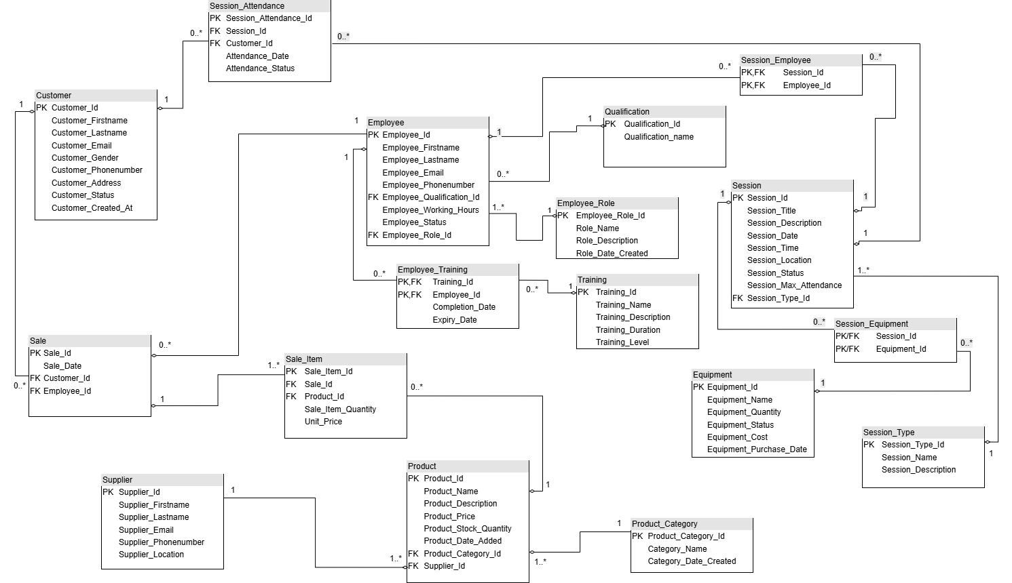

Justification of the ERD and the adherence to Third Normal Form(3NF) principles
- Unormalized Data
The initial dataset which was provided in the scenario was in an unstructured format resembling a flat file. It had multiple mixed entities such as Customers, Sessions, Employees, Equipment and Products). This design resulted in hgh redundancy and data inconsistency.
Attributes for instance Employee_Assigned, Equipment_Used and Product_Purchased contained multiple values within a single cell thereby violating the principles of atomicity. In addition, session details were repeatedly stored for each and every customer attending the same session leading to data duplication, anomalies during updates and wasting of storage space.
Furthermore, the dataset lacked clearly defined Primary Keys to uniquely identify each record resulting in data retrieval and management difficulty.
- First Normal Form(1NF)

A table is considered to be First Normal Form if it contains no repeating groups, primary key is available in the table.
Therefore, to achieve this there was a need to decompose the unnormalized data into separate entities for example Customer, Employee, Product, Equipment and Session. Multivalued attributes such as Customer_Name were splitted into Customer_Firstname and Customer_Lastname.
Primary Keys like Customer_Id, Employee_Id, Product_Id were introduced in each and every table to ensure that each row is uniquely identifiable.
- Second Normal Form(2NF)
Second Normal Form is achieved when a table is in First Normal Form and all partial key dependencies are removed from the table.
To satisfy rules of Second Normal Form, Composite tables such as Sale_Item, Session_Employee and Session_Equipment were introduced to resolve many-to-many relationships by ensuring that attributes depends on full composite key rather than part of it.
For instance, Product details were separated from Sale_Item table so that product information depends only on Product_Id and not on Sale_Id. This approach removed redundancy and improved data intergrity.

- Third Normal Form(3NF)
Third Normal Form is achieved when a table is in 2NF and all transitive dependencies are removed, meaning non-key attributes must not depend on other non-key attributes.
To achieve Third Normal Form, there was a need to decompose the tables further. For instance, Employee data was split into separate entities like Employee_Role, Employee_Qualification and Employee_Training. This was to make sure that role and qualification details were not repeatedly stored within the Employee table but instead represented by Foreign Keys.
Similarly, the Product_Category table was created to remove dependency of category details from the Product table. This result in category information being stored only once and reference where needed.
This structure reduces redundancy, improves consistency, security and ensures efficient database maintenance.
- Entity Relational Diagram(ERD Design Issue(FAN Trap and Chasm Trap Resolution)
During the design of the Entity Relational Diagram (ERD). Careful measures were taken were followed to avoid Chasm Trap and Fan Trap which can lead to incorrect query results and inconsistency of data. A Fan Trap occurs when single entity is connected to two or more entities in a way that it results into unclear relationships during querying. On the other hand, a Chasm Trap occurs when entities appear to be connected in an ERD but some relationships are optional which leads to missing data during Joins.

In this database, a potential Fan Trap existed between the Customer, Sale and Product entities. If sakes data was stored directly inside a single table. This could result in anomalies such as miscalculating total purchases per customer due to multiple product relationships being interpreted incorrectly. To resolve this issue Sale_Item entity was introduced in beween the Sales entity and Product entity. This ensures that One Sale can contain many products, each Product can belong to many Sales and Quantities and unit price are stored correctly at transaction level. This removes indirectness and ensure accurate reporting.

On the other hand, Chasm Trap in this system could have occurred between Session, Employee and Equipment. This is because Not all sessions may require employees and not all sessions may use equipment. If this is not handled properly, queries could return incomplete results when joining the entities. The best way to resolve this was to introduce Session_Employee and Session_Equipment entities making sure Many-to-many relationships are properly manages, optional participation does not break query results and no data is lost during joins.

Resolving Fan Trap and Chasm Trap issues through normalization and the use of associative entities ensures accurate querying, data intergrity and efficient design compliant with Third Normal Form(3NF)

- Data Dictionary

- Customer
Field Name | Data Type | Length | Constraints | Description | Sample Values
Customer_id | INT | - | PRIMARY KEY, AUTO_INCREMENT, NOT NULL | Unique Identifier for Customer | 1,2,3
Customer_Firstname | VARCHAR | 30 | NOT NULL | Customer’s first name | John, Sarah
Customer_Lastname | VARCHAR | 30 | NOT NULL | Customer’s last name | Banda, Phiti
Customer_Email | VARCHAR | 100 | UNIQUE, NOT NULL | Customer’s email address | John@gmail.com
Customer_Gender | VARCHAR | 30 | CHECK (‘Male’,’Female’) | Customer’s gender | Male
Customer_Phonenumber | VARCHAR | 15 | NN | Customer phone number | +2651243675
Customer_Address | VARCHAR | 100 | NOT NULL | Customer’s mailling address | BOX-20663,  BOX-1900, BOX-3
Customer_Status | VARCHAR | 20 | DEFAULT ‘Active’ | Customer’s status either active or not active | Active, Inactive
Customer_Created_At | TIMESTAMP | - | DEFAULT CURRENT_ TIMESTAMP | Records customer registration date and time | 2026-05-29 01:48:07, 2026-04-29 11:48:07, 2026-05-29 01:48:20

- Employee_Role
Field Name | Data Type | Length | Constraints | Description | Sample Values
Role_Id | INT | - | PRIMARY KEY, AUTO_INCREMENT, NOT NULL | Unique Identifier for Employeed role’s table | 1,2,3
Role_Name | VARCHAR | 50 | UNIQUE, NOT NULL | Role title | Sales Associate, Manager
Role_Description | TEXT | - | NOT NULL | Short description of the responsibilities | “Handles customer sales”
Role_Date_Created | DATE | 1- | UNUQIE, NOT NULL | The sections records date and time for role creation | 2026-01-1 09:00:00

c.Employee_Qualification
Field Name | Data Type | Length | Constraints | Description | Sample Values
Qualification_Id | INT | - | PRIMARY KEY, AUTO_INCREMENT, NOT NULL | Unique Identifier for Employeed Qualification | 1,2,3
Qualification_Name | VARCHAR | 100 | UNIQUE, NOT NULL | Qualification name | Diploma in Organic Chemistry

C.Employee
Field Name | Data Type | Length | Constraints | Description | Sample Values
Employee_Id | INT | - | PRIMARY KEY, AUTO_INCREMENT, NOT NULL | Unique Identifier for Employees’s table | 1,2,3
Employee_Firstname | VARCHAR | 30 | NOT NULL | Employee first name | Peter
Employee_Lastname | VARCHAR | 30 | NOT NULL | Employee last name | Zuze
Employee_Email | VARCHAR | 100 | UNIQUE, NOT NULL | Employee email address | peter@gmail.com
Employee_Phonenumber | VARCHAR | 15 | NOT NULL | Employee phone number | +26599201829
Employee_Working_Hours | INT | - | NOT NULL | Daily working hours | 8
Employee_Status | VARCHAR | 100 | DEFAULT ‘Active’, NOT NULL | Employee employment status | Active
Role_Id | INT | - | FOREIGN KEY, NOT NULL | Section references assigned Job role | 1
Qualification_Id | INT | - | FOREGIN KEY,NOT NULL | Section references Employee_Role table | 1

g.Supplier
Field Name | Data Type | Length | Constraints | Description | Sample Values
Supplier_Id | INT | - | PRIMARY KEY, AUTO_INCREMENT NOT NULL | Unique identifier for Supplier table | 1,2,3
Supplier_Name | VARCHAR | 100 | NOT NULL | Supplier’s business name | AgriSupplies Ltd
Supplier_Email | VARCHAR | 100 | NOT NULL | Supplier email | info@agrisupplies.mw
Supplier_Phonenumber | VARCHAR | 15 | NOT NULL | Supplier phonenumber | +265991244213
Supplier_Location | VARCHAR | 100 | NOT NULL | Supplier location | Lilongwe

- Employee_Qualification
Field Name | Data Type | Length | Constraints | Description | Sample Values
Qualification_Id | INT | - | NOT NULL | Unique identifier section for qualification table | 1,2,3
Qualification_Name | VARCHAR | 100 | UNIQUE ,NOT NUU | Qualification or certificate name | Diploma In Crop Systems, Degree in Agricultural Marketing, Certificate in Sales Management

Training_Description | TEXT | - | NOT NULL | Descriptiong of training | Understanding soil composition
Training_Duration | VARCHAR | 20 | NOT NULL | Duration of the training | 3 days
Training_Level | VARCHAR | 20 | NOT NULL | Level of difficulty for the training | Beginner, Intermediate, Advanced

h.Product_Category
Field Name | Data Type | Length | Constraints | Description | Sample Values
Category_Id | INT | - | PRIMARY KEY, AUTO_INCREMENT, NOT NULL | Unique category identifier | 1,2,3
Category_Name | VARCHAR | 50 | UNIQUE, NOT NULL | Product category name | Plants, Accessoriy

i.Product
Field Name | Data Type | Length | Constraints | Description | Sample Values
Product_Id | INT | - | PRIMARY KEY, AUTO_INCREMENT NOT NULL | Unique identifier for Product table | 1,2,3
Product_Name | VARCHAR | 100 | NOT NULL | Product name | Rose Plant
Product_Description | TEXT | - | NOT NULL | Product Description | It’s a Hybrid tea rose
Product_Price | DECIMAL | 10,2 | NOT NULL | Product selling price | 10000.00
Product_Stock_Quantity | INT | - | NOT NULL | Quantity available in stock | 20
Product_Date_Added | DATE | - | NOT NULL | Date the product was added | 2026-04-20
Category_Id | INT | - | FOREIGN KEY, NOT NULL | Section referencing Product_Category table | 1
Supplier_Id | INT | - | FOREIGN KEY, NOT NULL | Section referencing Supplier table | 1

e.Training
Field Name | Data Type | Length | Constraints | Description | Sample Values
Training_Id | INT | - | PRIMARY KEY, , AUTO_INCREMENT, NOT NULL | Unique identifier for Training table | 1,2,3
Training_Name | VARCHAR | 100 | NOT NULL | Training tite | Soil Health
Training_Descption | TEXT | - | NOT NULL | Description of the training | Understanding soil composition
Training_Duration | VARCHAR | 20 | NOT NULL | Amount of time for training | 3 days
Training_Level | VARCHAR | 20 | NOT NULL | Level of difficulty for the training | Beginner

f.Employee_Training
Field Name | Data Type | Length | Constraints | Description | Sample Values
Training_Id | INT | - | PRIMARY KEY, NOT NULL | Unique identifier for Employee Training Table | 1
Employee_Id | INT | - | PRIMARY KEY, FOREIGN KEY | Foreign key referencing the Employee table | 2
Completion_Date | DATE | - | NOT NULL | Date of training completion | 2026-01-15
Expiry_Date | DATE | - | NOT NULL | Training expiration date | 2027-06-15

k. Session_Type
Field Name | Data Type | Length | Constraints | Description | Sample Values
Session_Type_Id | INT | - | PRIMARY KEY, NOT NULL | Unique identifier for Employee Training Table | 1,2
Session_Name | VARCHAR | 100 | UNIQUE, NOT NULL | Session type name | Workshop
Session_Description | TEXT | - | NOT NULL | Description of session type | Practical training session

i.Session
Field Name | Data Type | Length | Constraints | Description | Sample Values
Session_Id | INT | - | PRIMARY KEY, NOT NULL | Unique identifier for Employee Training Table | 1
Session_Title | VARCHAR | 100 | NOT NUL | Foreign key referencing the Employee table | 2
Session_Description | DATE | - | NOT NULL | Date of training completion | 2026-01-15
Session_Date | DATE | - | NOT NULL | Training expiration date | 2027-06-15
Session_Time | TIME | - | NOT NULL | Time for the session | 09:00:00
Session_Location | VARCHAR | 100 | NOT NULL | The venue of the location | Main Hall
Session_Max_Attendance | INT | - | NOT NULL | Maximum number of people allowed to attend | 20
Status | VARCHAR | 20 | NOT NULL | Session status | Scheduled
Session_Type_Id | INT | - | FOREIGN KEY, NOT NULL | References | 1

m.Equipment
Field Name | Data Type | Length | Constraints | Description | Sample Values
Equipment_Id | INT | - | PRIMARY KEY, NOT NULL | Unique identifier for Employee Training Table | 1
Equipment_Name | VARCHAR | - | PRIMARY KEY, FOREIGN KEY | Name of the equipment | Shovel
Equipment_Quantity | INT | - | NOT NULL | Equipment total number available | 16
Equipment_Description | TEXT | - | NOT NULL | Equipment desciption | Steel spade with wooden handle
Equipment_Status | VARCHAR | 20 | NOT NULL | Equipment availability status | Available
Equipment_Cost | DECIMAL | 10,2 | NOT NULL | Cost covered when buying the equipment | 25000.00
Equipment_Purchase_Date | DATE | - | NOT NULL | Date the equipment was purchased | 2025-01-10

- Database Query

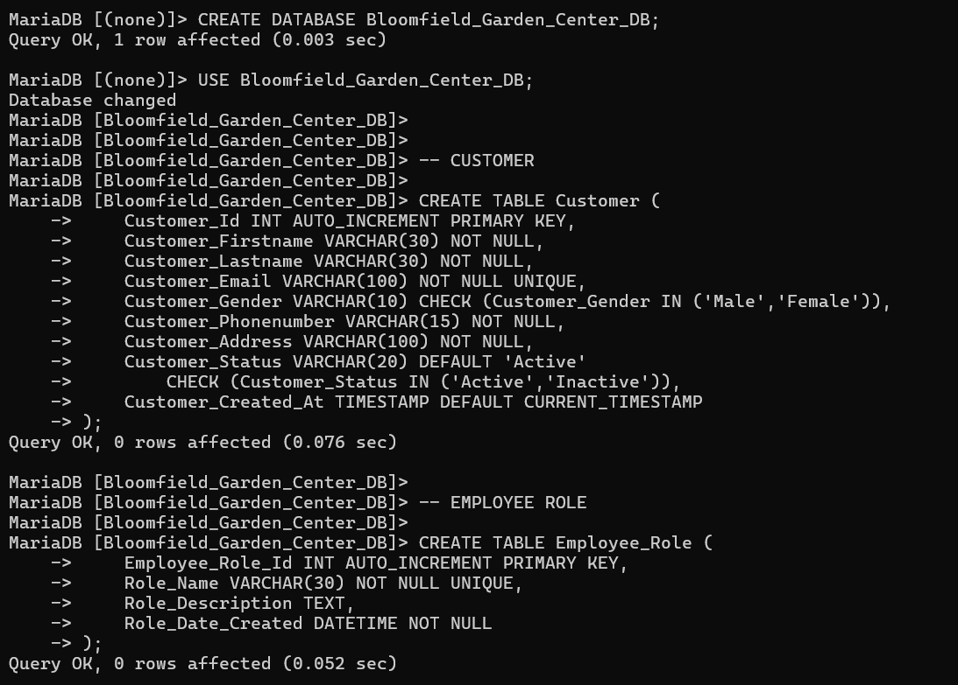
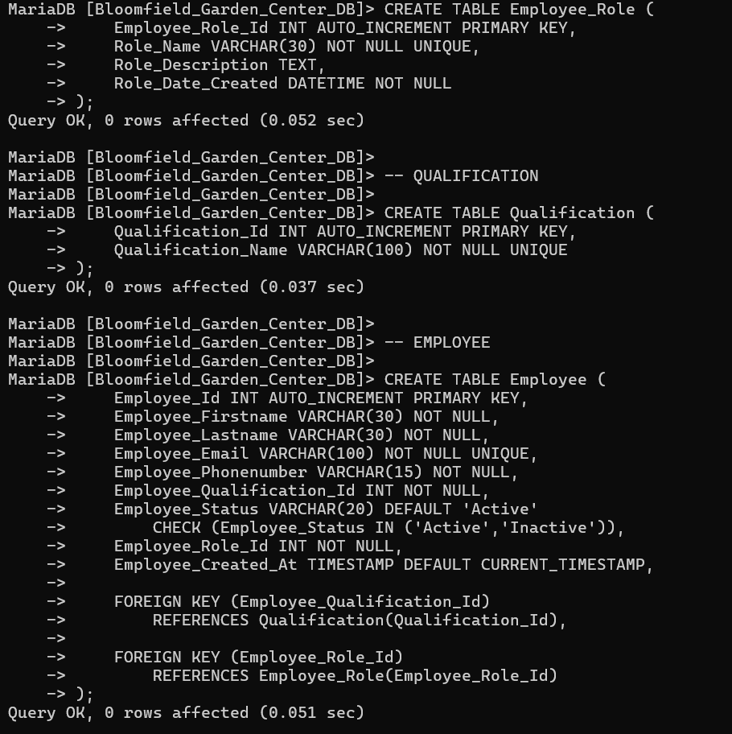
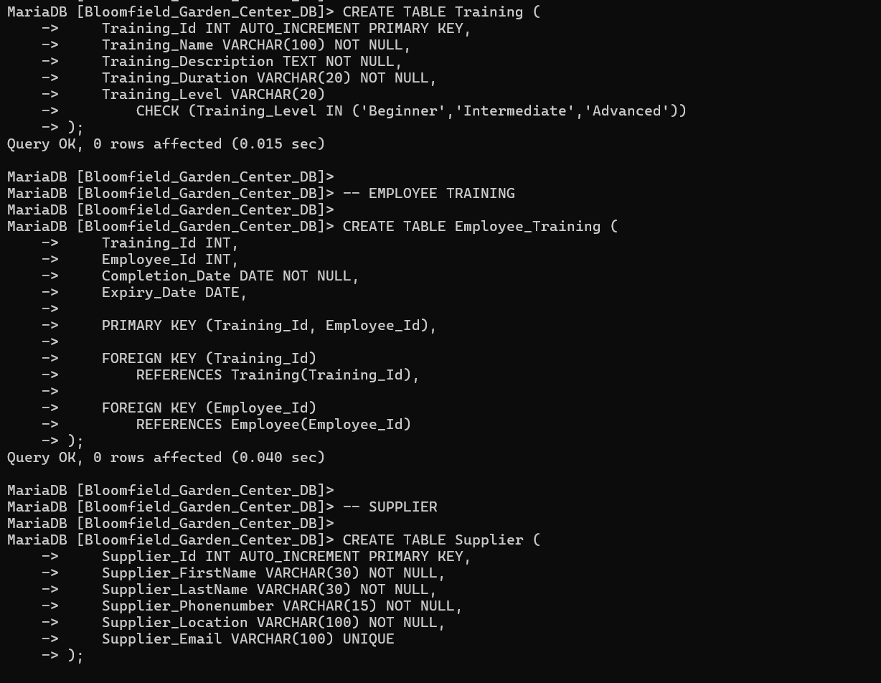
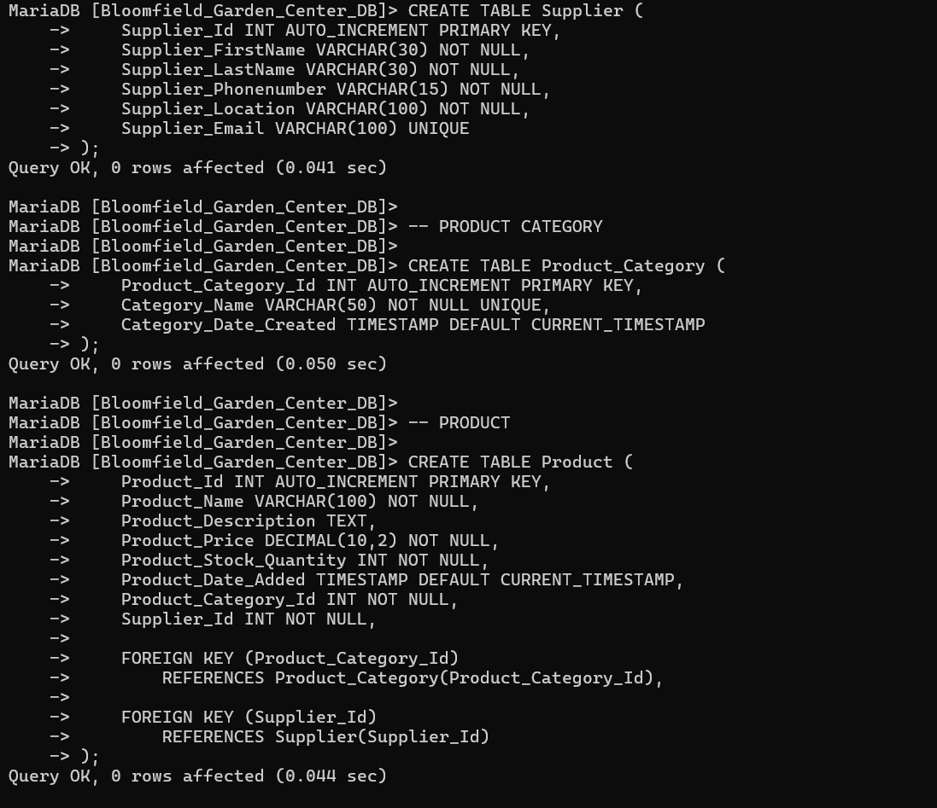
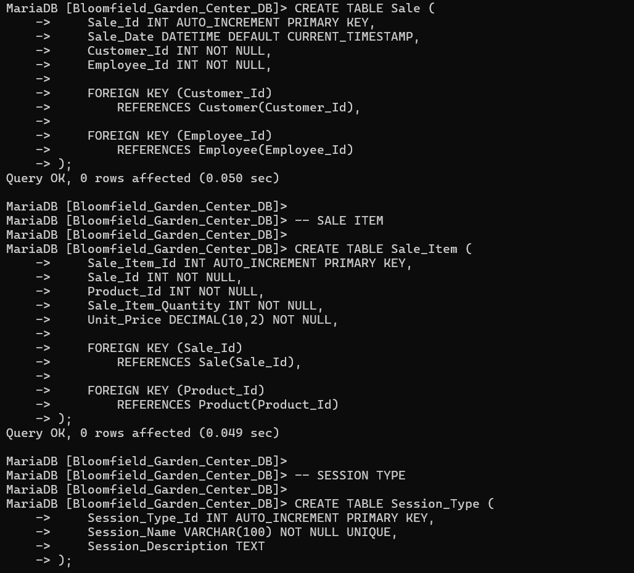
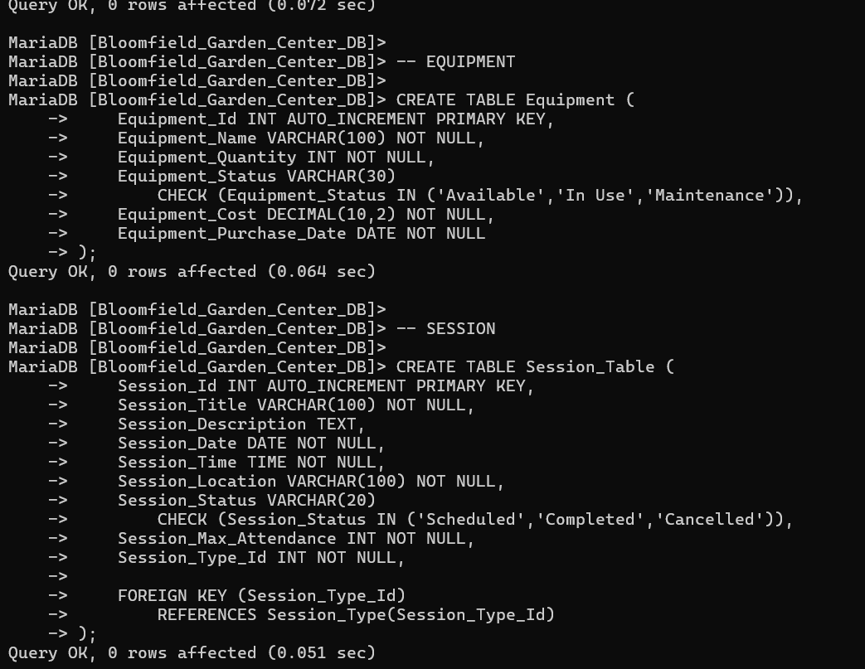
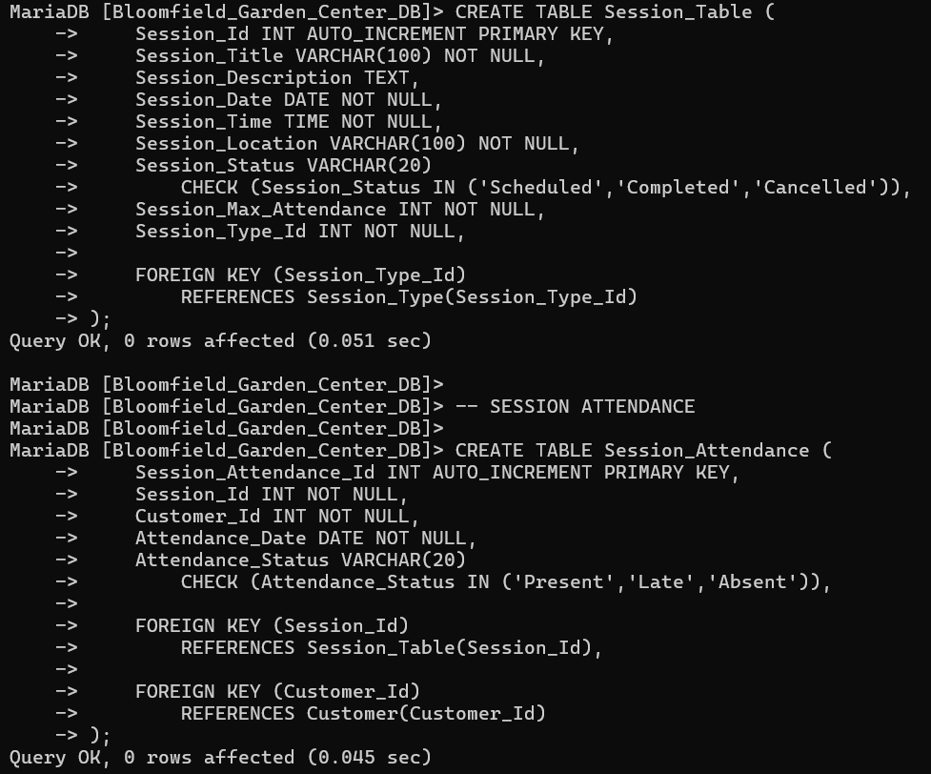
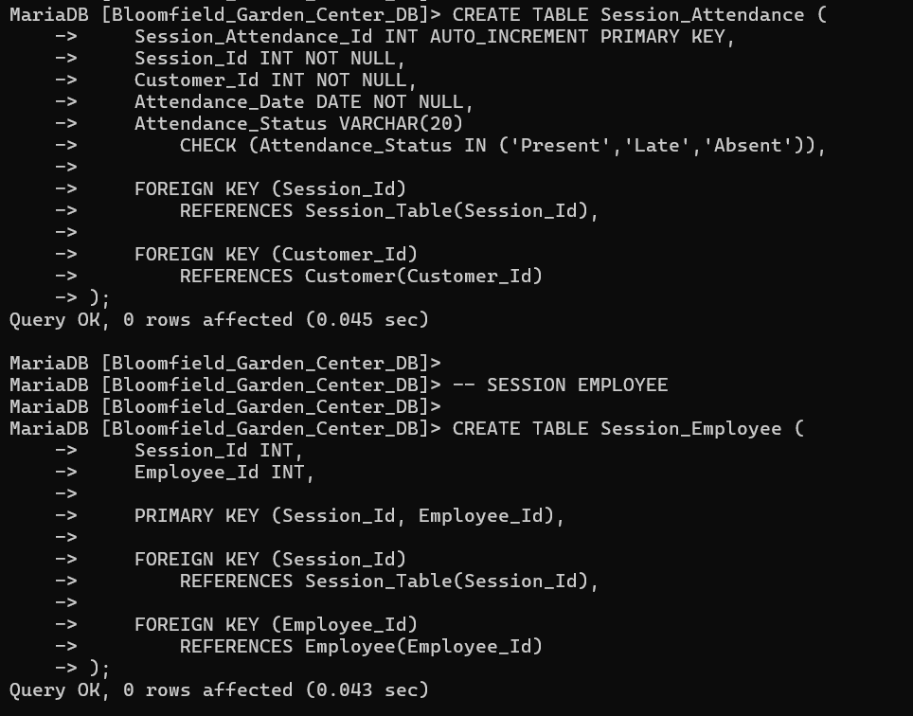
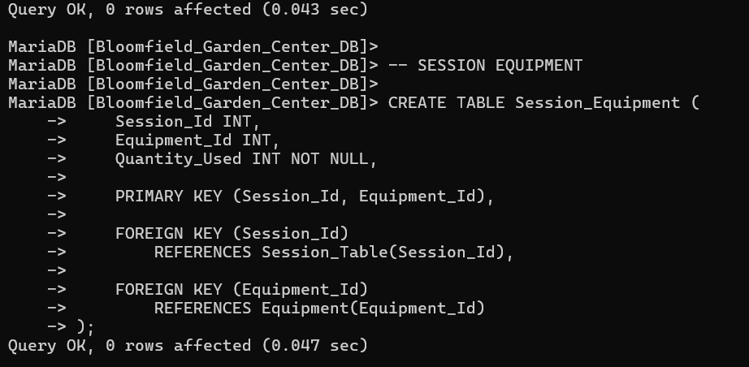

Inserting Data Into Tables
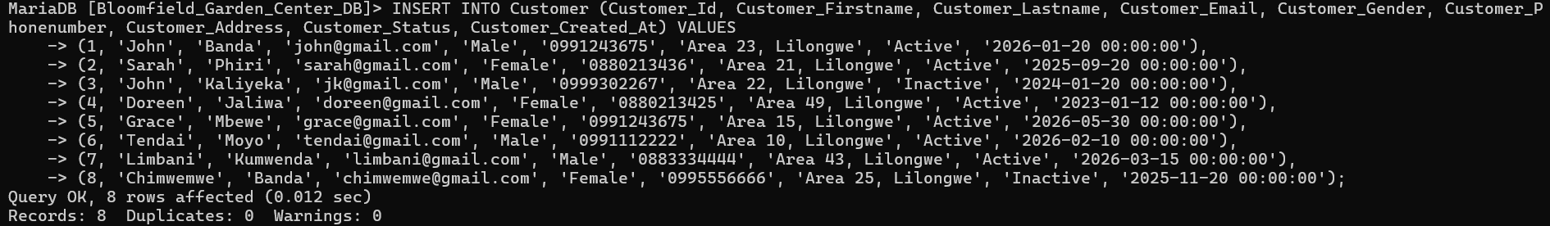
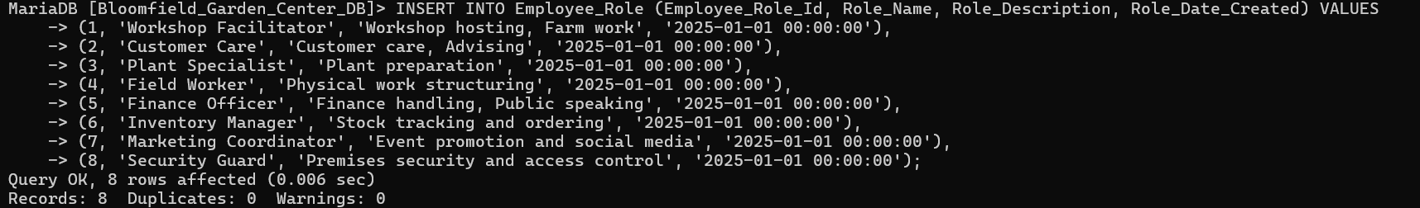
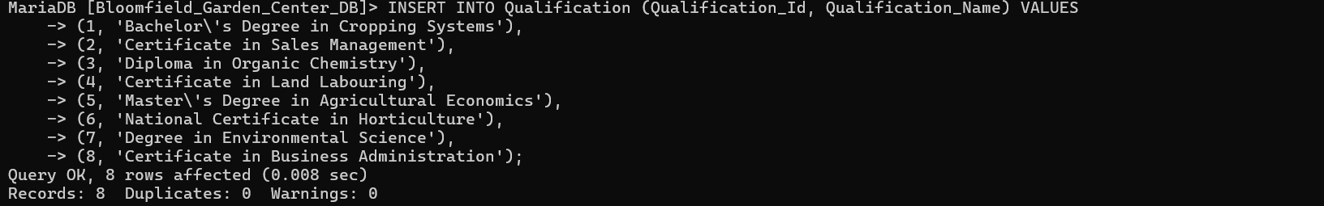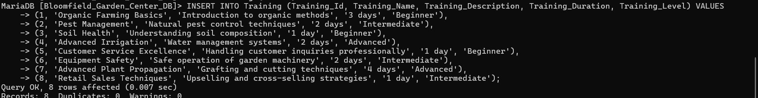
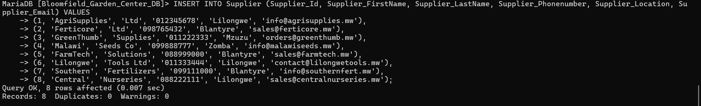
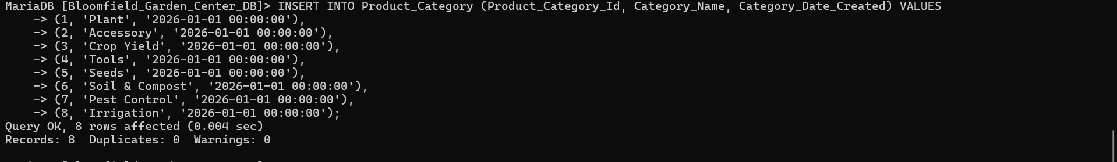
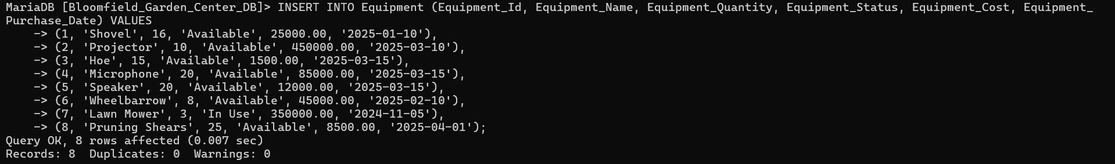
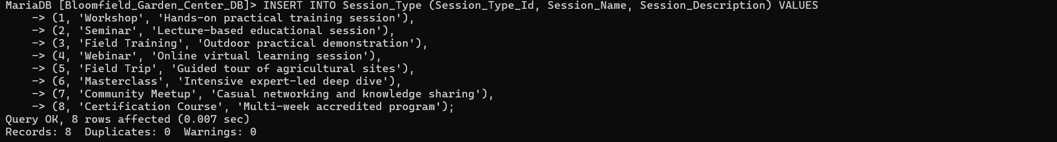
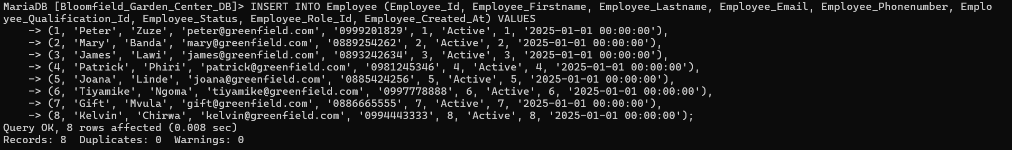
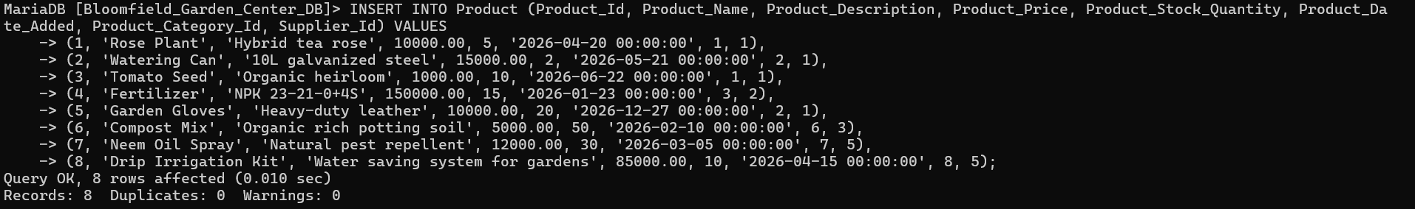
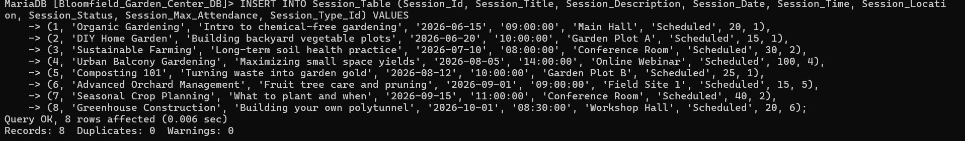
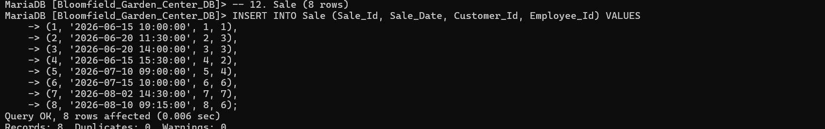
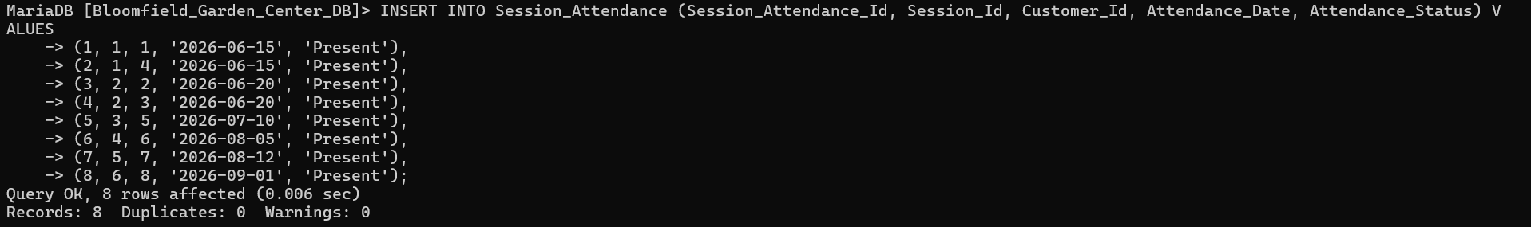
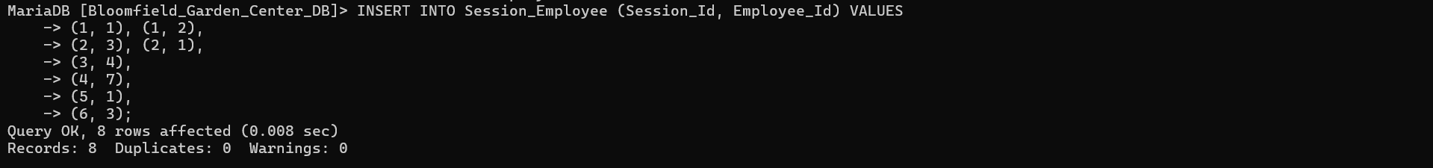
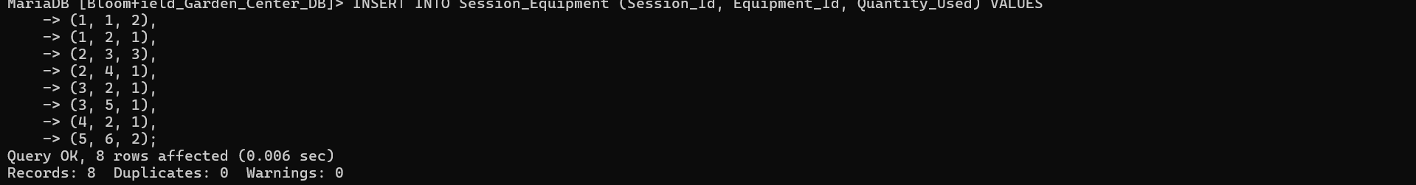
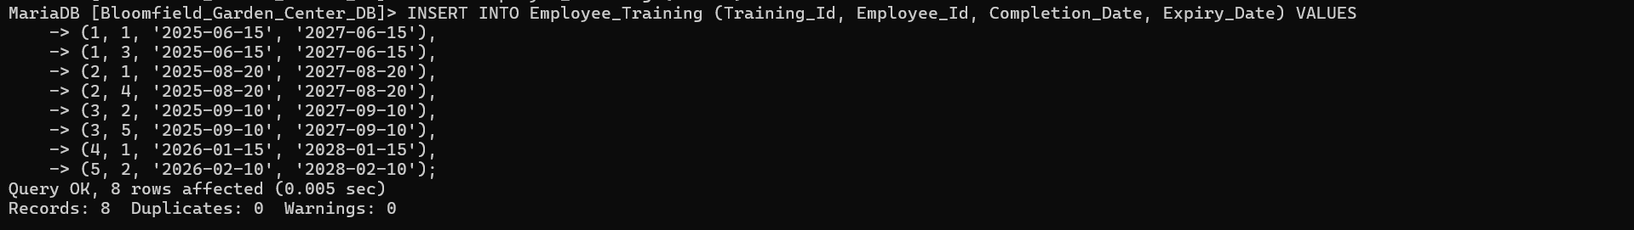
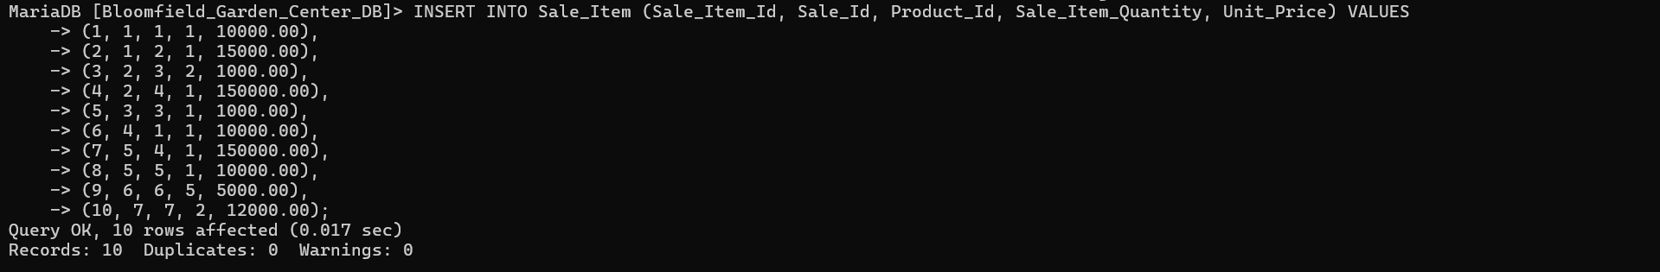

Table displaying

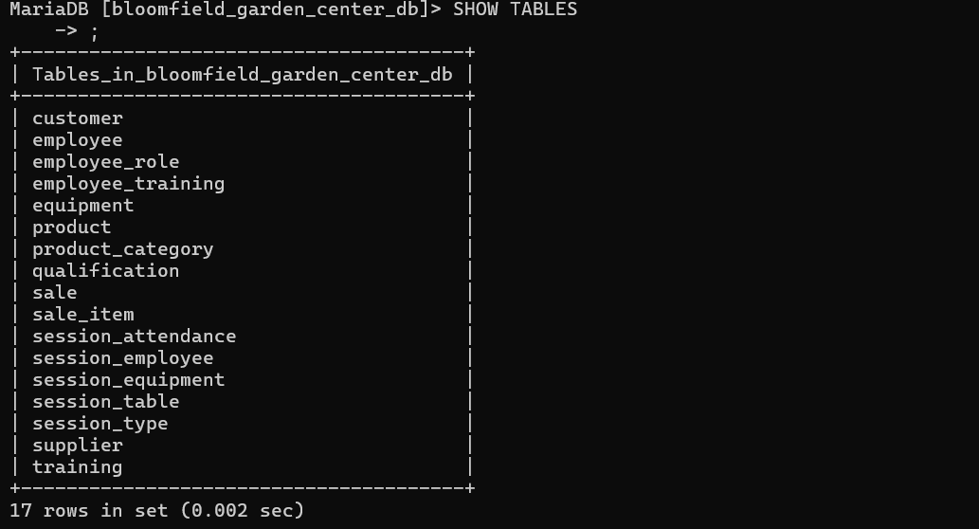
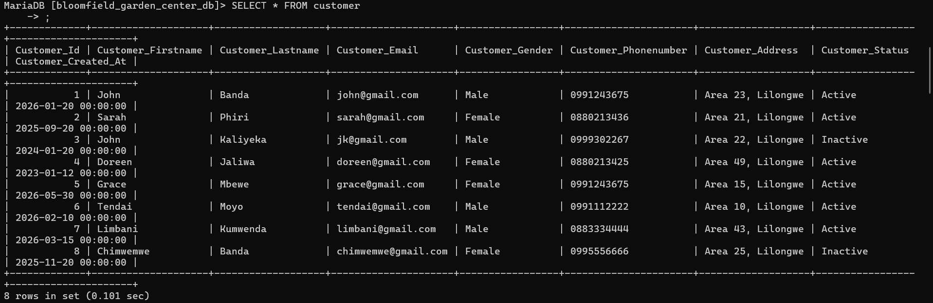
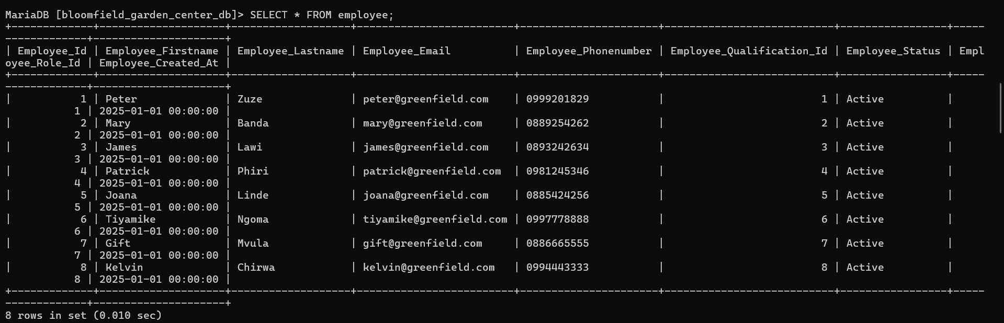
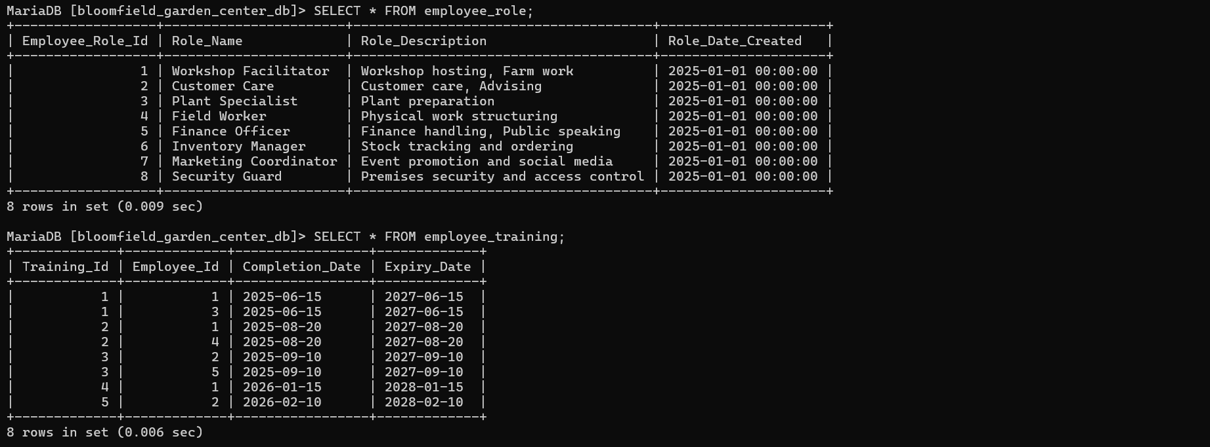
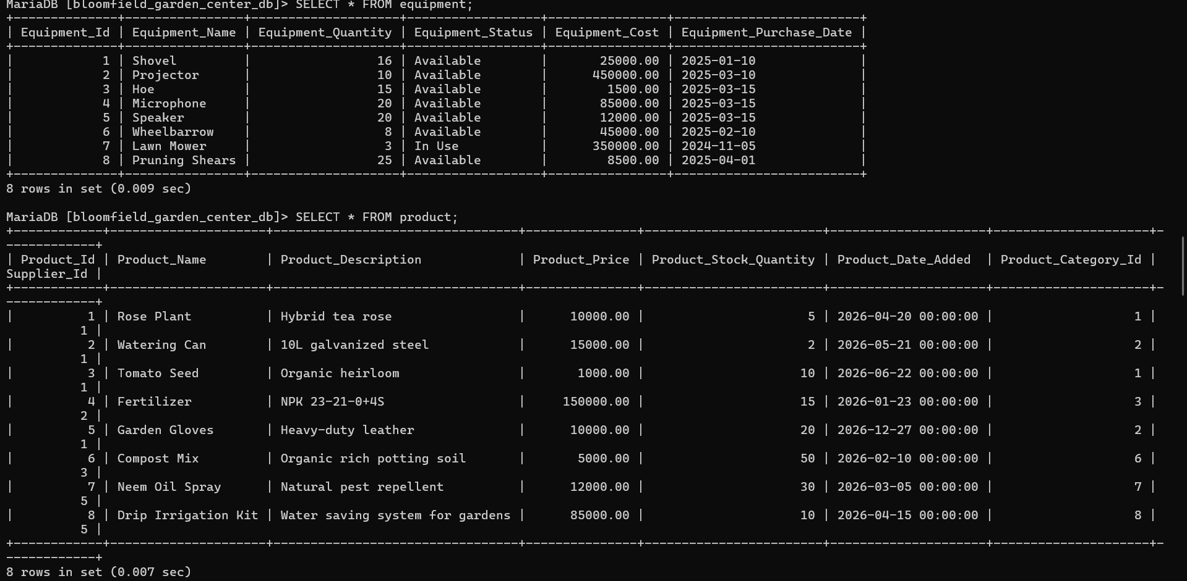
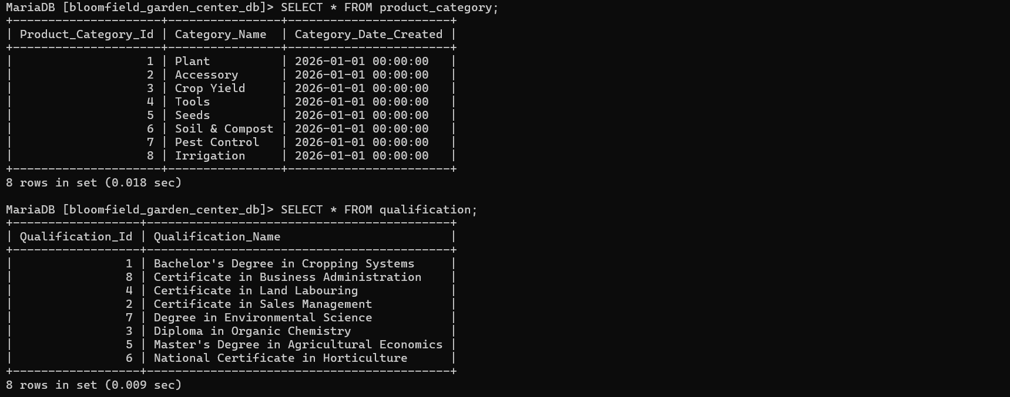
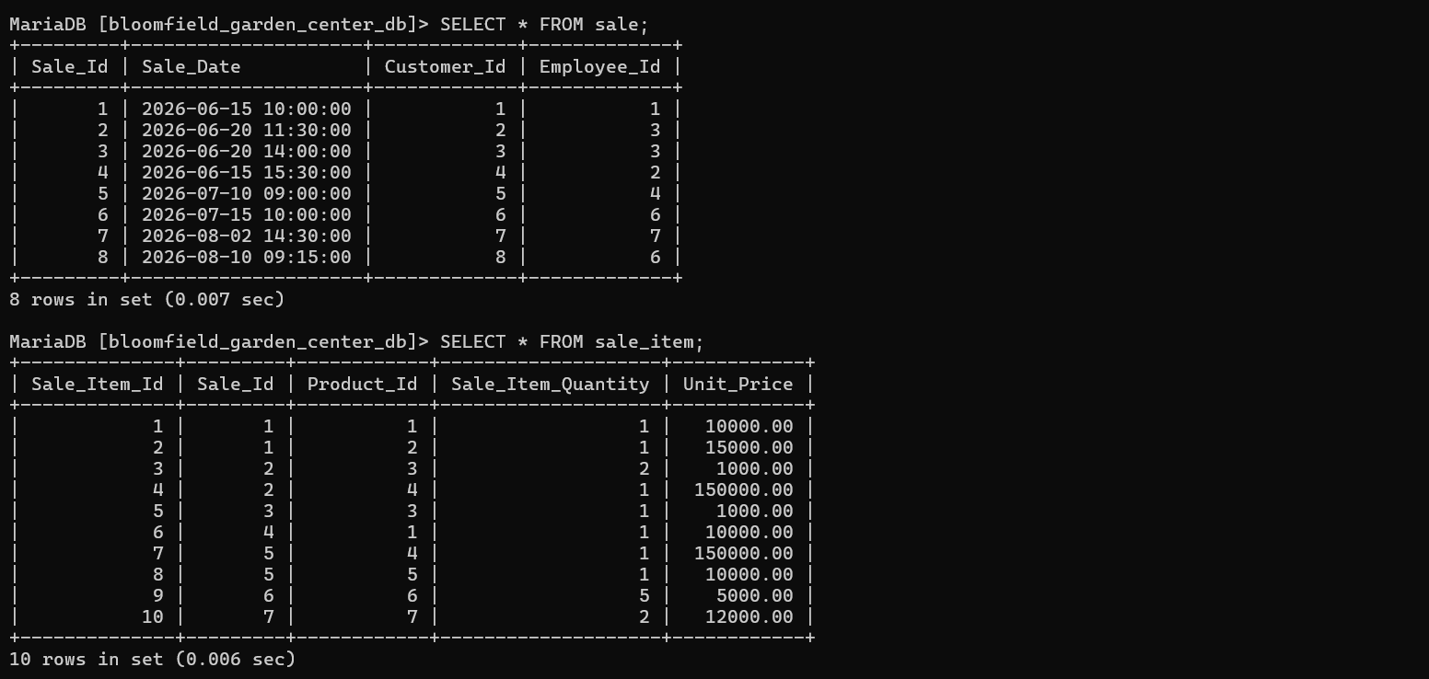
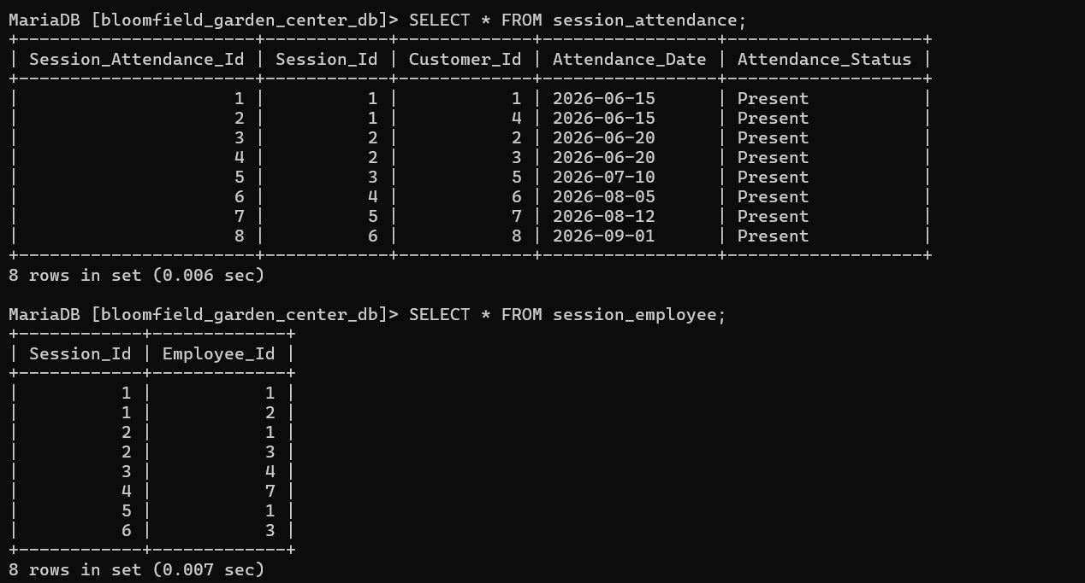
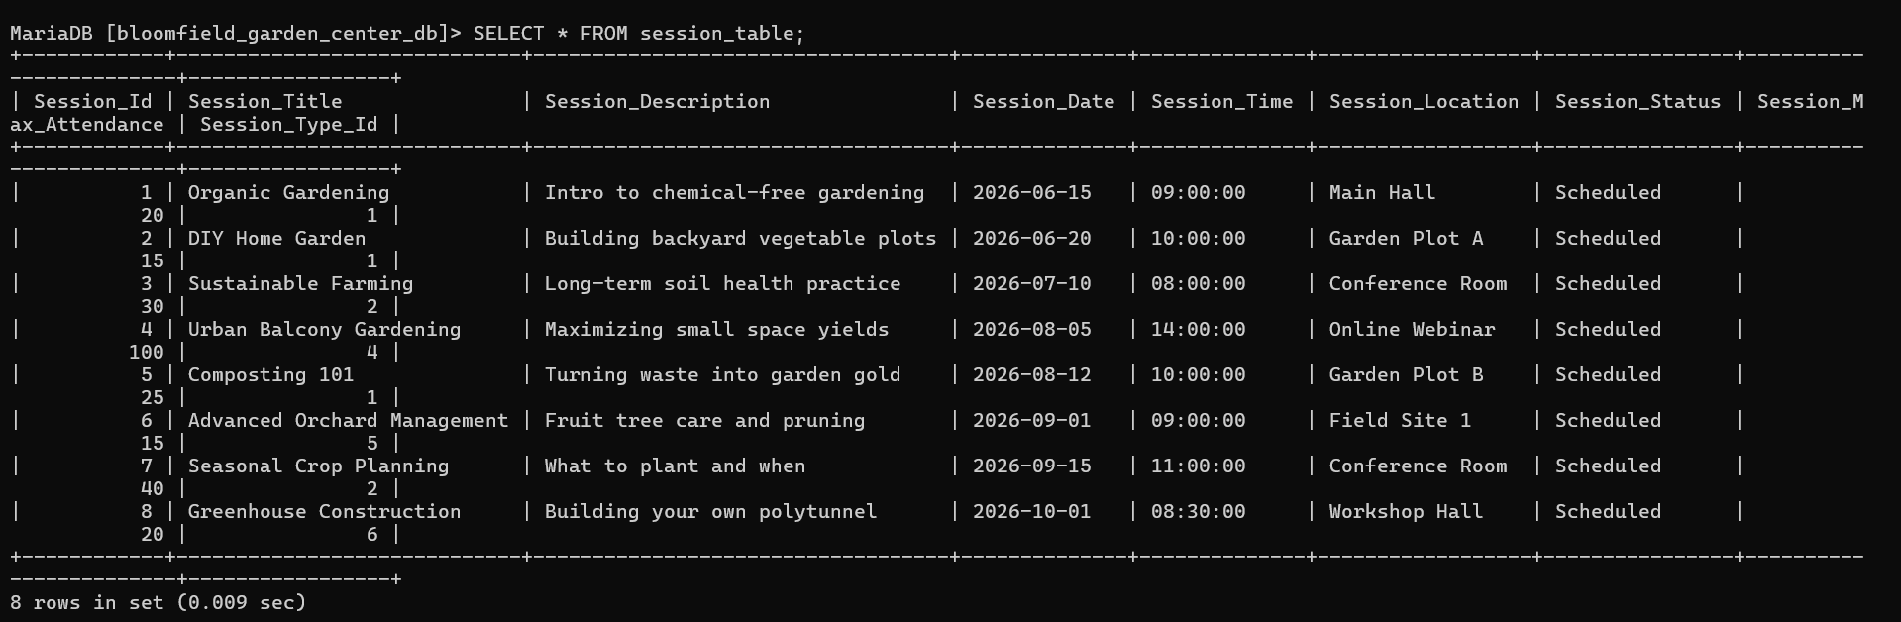
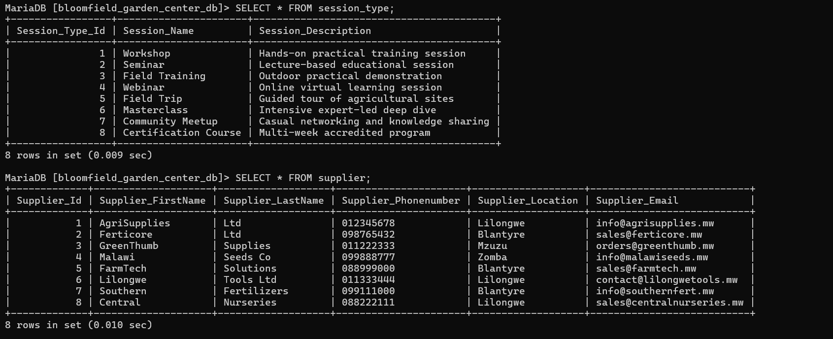
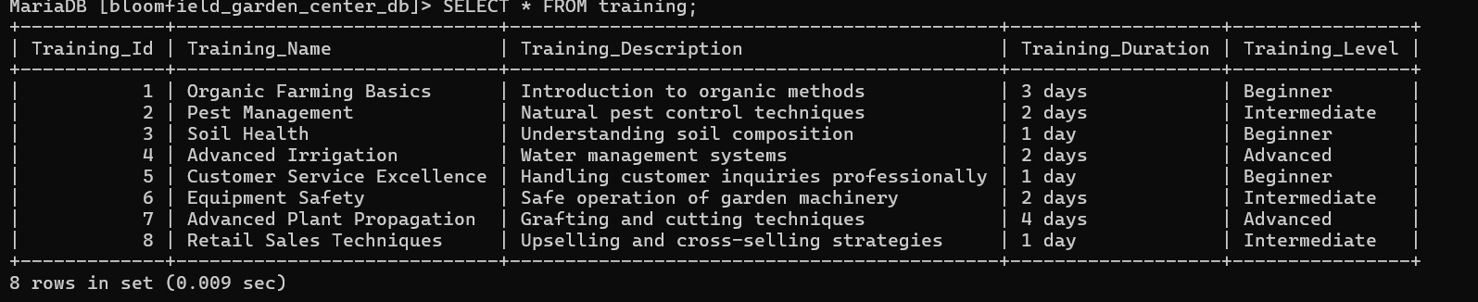

4.Role-based Access Control
- Justification of priviledges
Role | Table | Priviledges | Business Justification
Sales_role | product | SELECT | Employees on the sales side needs to view product names, prices and stock to assist customers. Therefore they must not alter prices or delete inventor/products to prevent fraud.
 | Sale | SELECT, INSERT | Sales employees must also be able to create new sales records and view transactions but they must not Update or DELETE sales to maintain strict trail for finance.
Admin_role | Product | SELECT,INSERT,UPDATE,DELETE | Adminstrators must have full CRUD control to the inventory. Admin can add new product, update product pricing, adjust stock counts and remove Products.
 | Sale | SELECT, INSERT, UPDATE, DELETE | Admininstrators require to be given full access to manage the database, correct errors and address suscipicious activities while ensuring auditability and security.

- SQL Implementation

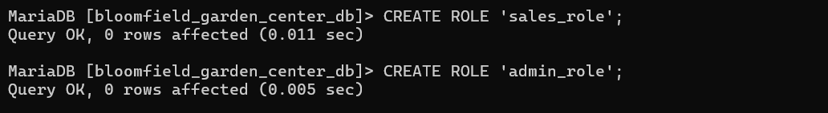
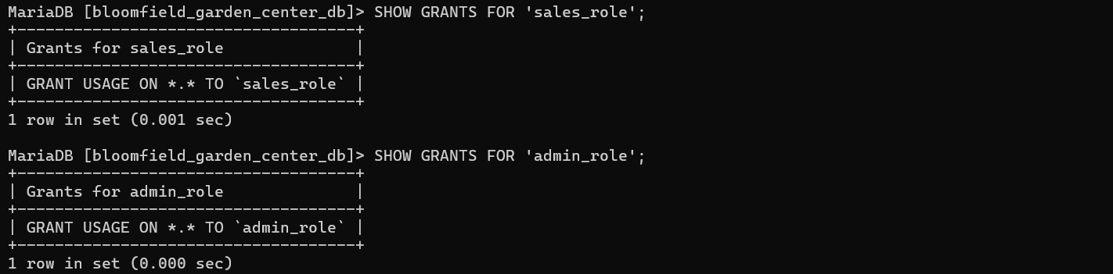
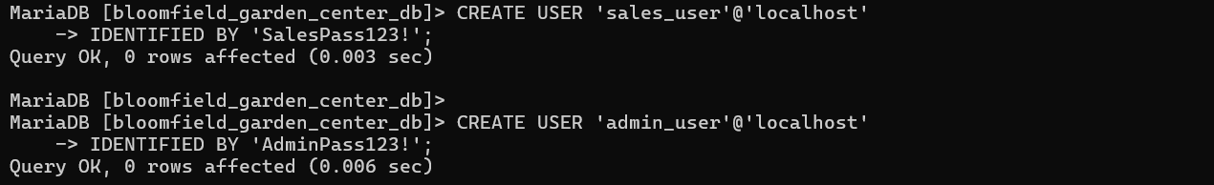
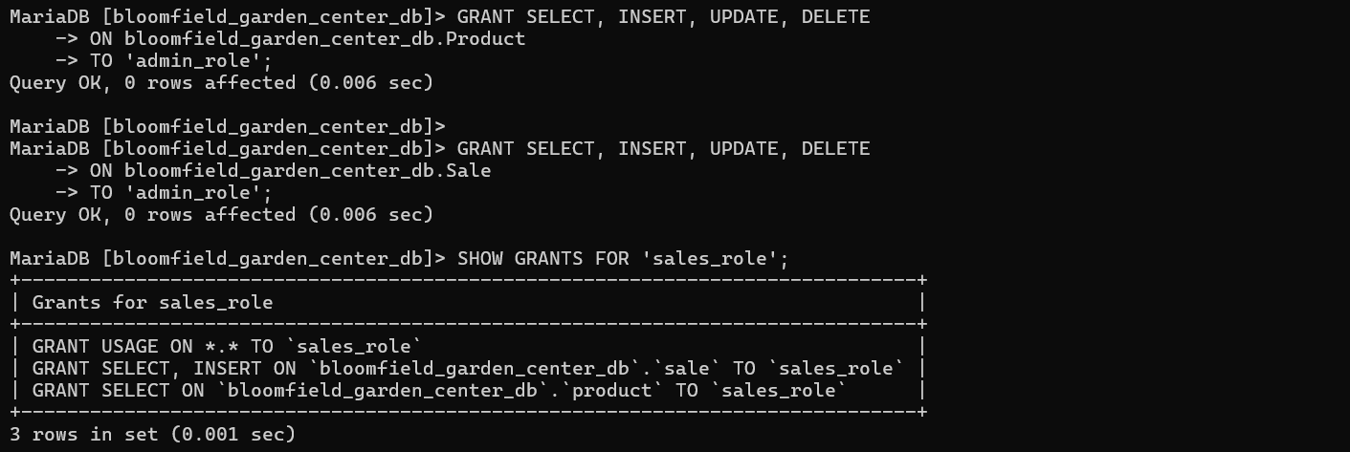
- Testing and Proof Execution
Test 1: sales user attempting to update a user’s product price

5.SQL Queries
